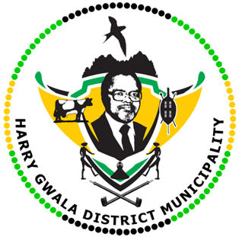
HARRY GWALA DISTRICT MUNICIPALITY
“Together We Deliver and Grow”
OFFICE OF THE MUNICIPAL MANAGER
40 Main Street, Private Bag X501, IXOPO 3276
Tel: (039) 834 8707 Fax: (039) 834 1701
Email: NgubaneN1@harrygwaladm.gov.za

26 February 2023
PUBLIC NOTICE
DISRUPTION OF WATER SUPPLY

Harry Gwala District Municipality has noted that the water supply is affected in the following areas: Underberg, Himeville, some areas in IXopo and UMzimkhulu.
The Municipality wishes to apologise to the customers who are affected by the unforeseen problem, the municipality is addressing it.
To this end please note that there are attempts at the highest level to have this resolved as soon as possible.
Harry Gwala District Municipality apologies
to all its consumers for the inconvenience caused. It is our commitment to keep you informed.
For further information please contact our offices:
Municipality switchboard Customer Care: 0860103651
End.
Issued by Harry Gwala District Municipality Communications Unit.

